Ideation Phase
Define the Problem Statements

Date | 3 october 2026
Team ID | SWTID-2026-6064
Project Name | Streamlining IT Procurement: Automating Standard Laptop Orders with Flow Designer
Maximum Marks | 2 Marks

Customer Problem Statement Template:
Create a problem statement to understand the customer's point of view. The Customer Problem Statement helps the team focus on the challenges faced by the customer and identify opportunities for improvement.
For our project, the customer is an employee requesting a standard laptop, while the IT procurement and Hardware team are responsible for processing, configuring, and delivering the laptop.

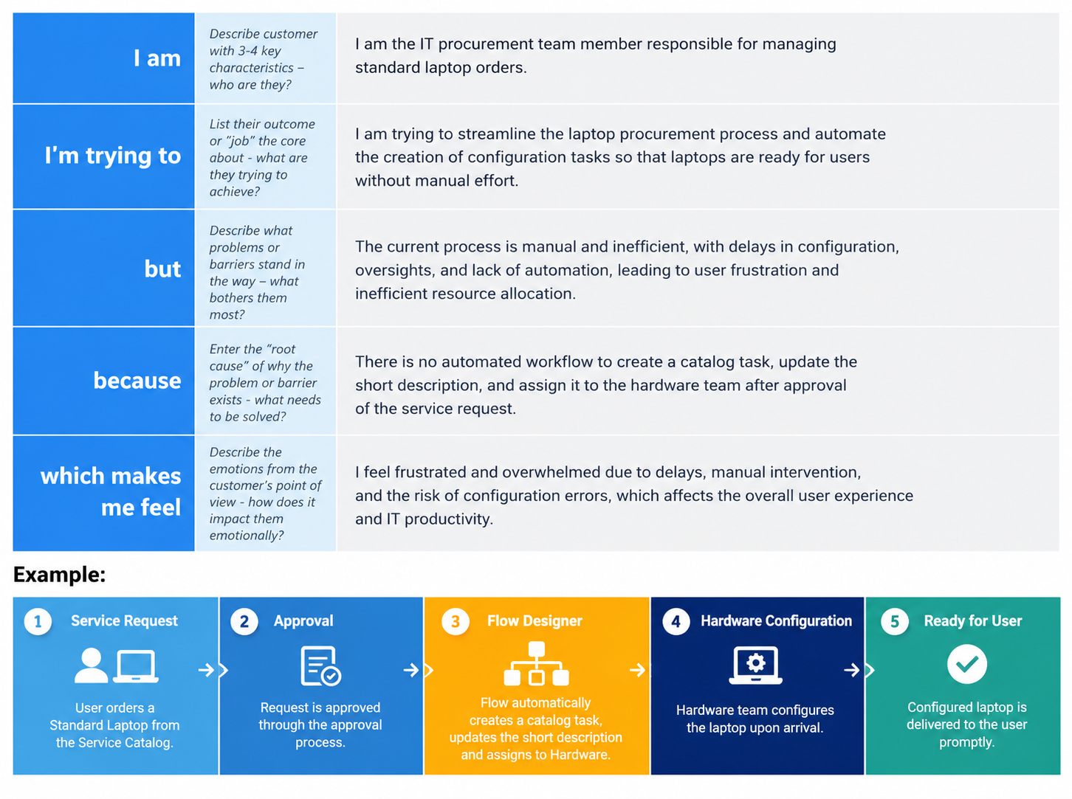

Problem Statement (PS) | I am (Customer) | I’m trying to | But | Because | Which makes me feel
PS-1 | An employee requesting a standard laptop | Get my laptop configured and ready on time | The configuration task may be delayed or overlooked after approval | The current process involves manual task creation and assignment | Frustrated and concerned about the waiting time
PS-2 | An IT procurement team member | Ensure every approved laptop request reaches the Hardware team |  | Manual intervention can cause delays and inefficient resource allocation | Overloaded and concerned about missed or delayed tasks
  every approved laptop request reaches the Hardware team
  Configuration tasks require manual processing and assignment

Customer Problem Statement – PS-1
I am an employee requesting a standard laptop.
I'm trying to get my laptop configured and ready for use on time.
But the configuration task may be delayed or overlooked after my request is approved.
Because the current process requires manual task creation and assignment.
Which makes me feel frustrated and concerned about the waiting time.
Customer Problem Statement – PS-2
I am an IT procurement team member.
I'm trying to ensure that every approved Standard Laptop request is quickly assigned to the Hardware team for configuration.
But configuration tasks require manual processing and assignment.
Because the existing process has limited automation and can result in delays or missed tasks.
Which makes me feel overloaded and concerned about inefficient resource allocation.
Key Problem Identified
Approved Standard Laptop requests need an automated process that creates a Catalog Task and assigns it to the Hardware team for configuration.
Proposed Direction
Service Catalog → Approval → Flow Designer → Create Catalog Task → Hardware Assignment → Laptop Configuration

